**Hints**

* Add references to Tricentis.Automation.Interaction and Tricentis.AutomationBase
* Buffer operations are located in the class **SettingsBufferAccess** or **Buffers**
* Derive this time from base class SpecialExecutionTaskEnhanced for more detailed results
* [Embedding SETs in an XModule](https://documentation.tricentis.com/devcorner/1200/tboxapi/#topic32.html)
* Instead of compiling your SET into a dll file and deliver it to each computer, you can alternatively embed the cs file in your XModule.
* In this case the value of the XParam "SpecialExecutionTask" has to match the name of the attached file without the ".cs" ending.
* The file can only contain a single SpecialExecutionTask class, otherwise an exception will be thrown. The value of the XParam "Engine" can hold any value, it just has to exist.

After preparing all things in Tosca we move to Visual Studio.

The solution will only contain the cs file since we will use Embedding SETs.

If you want to use the cs file, make sure your XParam "SpecialExecutionTask” is named *SetBuffer*.



# BufferOperation

After setting things up in the Visual Studio project, we will copy and paste the provided snippet from the exercise sheet:

Ein Bild, das Text enthält.

To understand what we need to do, we will take a look into the Tosca Manual for Buffer (this exercise creates a SET of *TBox Set Buffer* and *TBox Name to Buffer*:

Ein Bild, das Text enthält.

Ein Bild, das Text enthält.

We must check the ActionMode of each TestStepValue and decide what we want to do:

(Renamed var parameter to var testStepValue to improve readability)

Ein Bild, das Text, Monitor, Screenshot, Elektronik enthält.

We follow the instructions from the video and add code for else:

Ein Bild, das Text, Screenshot, Monitor, Elektronik enthält.

Back to Tosca Commander

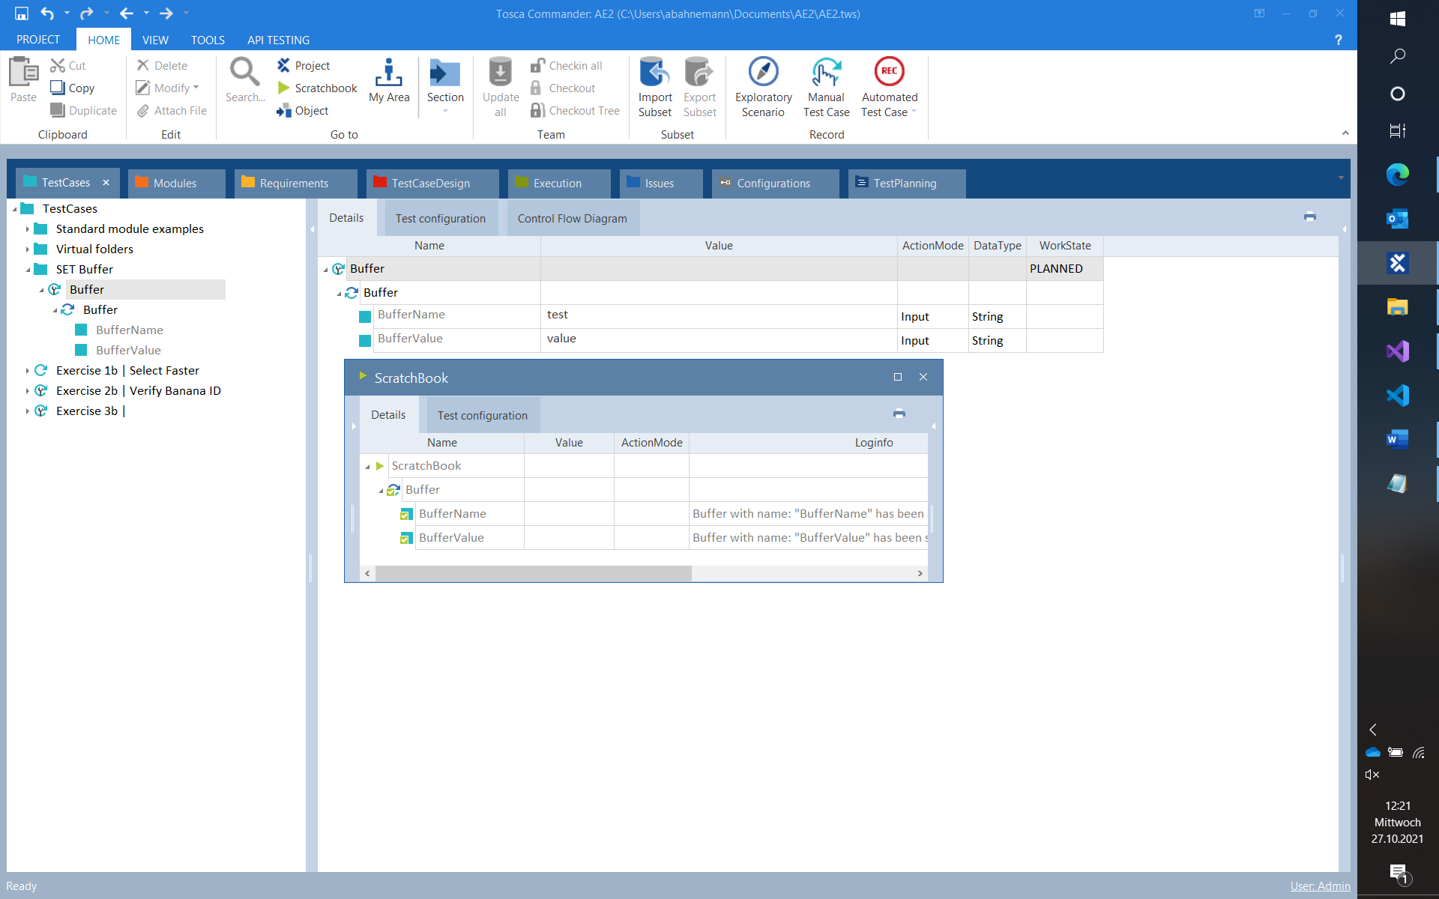

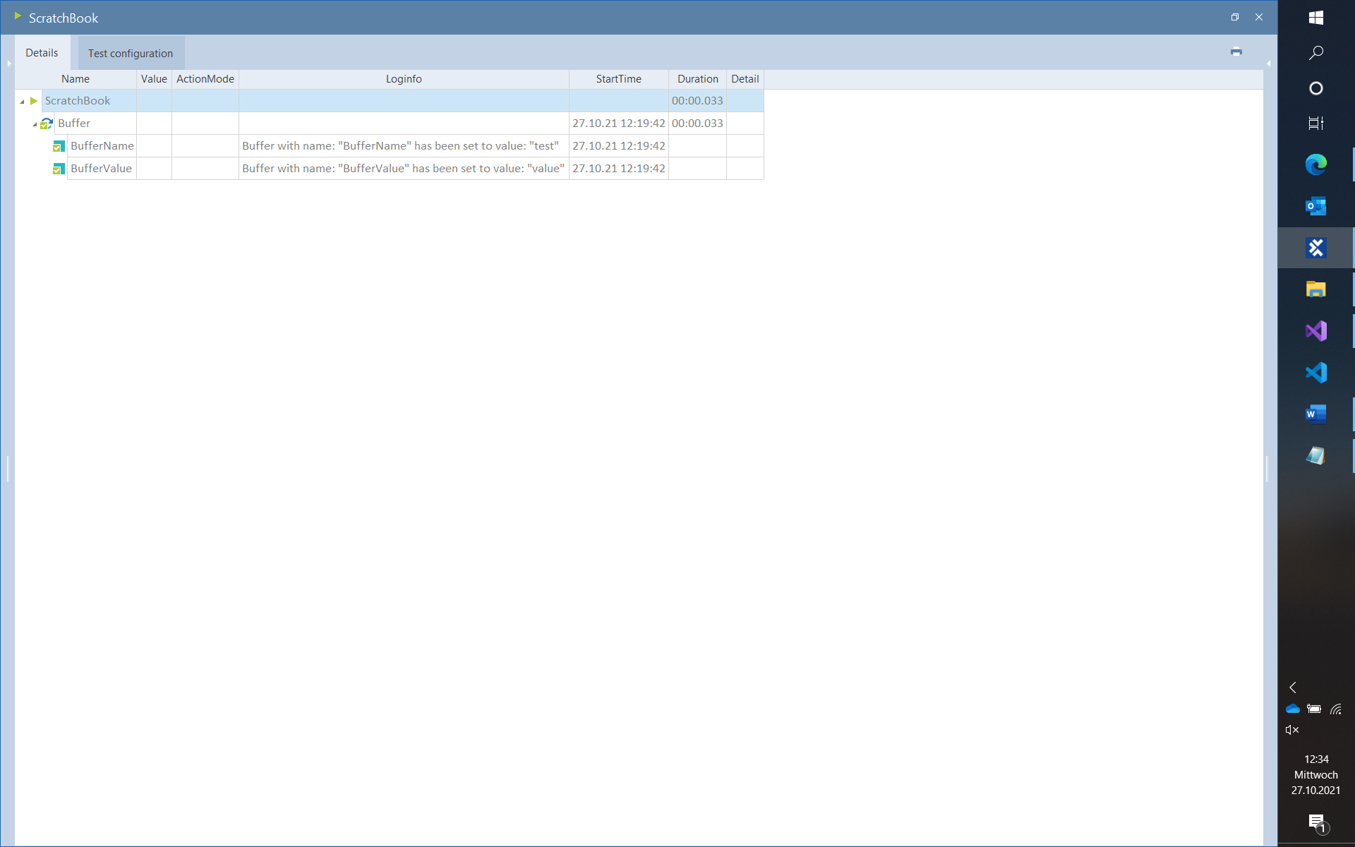

Enhanced testing in tosca Commander

Change/add properties Cardinality, ExplicitName for one Attribute or more:

Ein Bild, das Text, Screenshot, Computer, drinnen enthält.

Changed it for BufferName:

Ein Bild, das Tisch enthält.

